Coursework for Numerical Methods

By: David Clarke
Course: Electrical & Electronic Engineering2
Date:5/5/2000

1).
a). Maclaurin expansion of log_{e}(1.1)

Truncated to 4 terms:

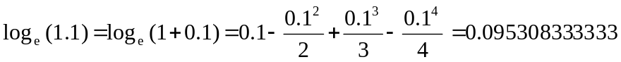

Truncated to 6 terms:

Truncated to 8 terms:

Accuracy of the estimated results against the actual calculator value

Using a calculator, log_{e}(1.1) is given as:

0.095310179804

If the calculator result is taken to be the exact value (X) with the truncated terms being taken as the estimates (x) the errors in the estimates (x) can be calculated using the equation below:

Error = X – x

- Error in the Maclaurin expansion evaluated to 4 terms =

0.095310179804 - 0.095308333333 = 1.846471326 E-6

- Error in the Maclaurin expansion evaluated to 6 terms =

0.095310179804 - 0.095310166667 = 1.3137326 E-8

- Error in the Maclaurin expansion evaluated to 8 terms =

0.095310179804 - 0.095310179702 = 1.02326 E-10

b). Maclaurin expansion of log_{e}(1.5)

Truncated to 4 terms:

Truncated to 6 terms:

Truncated to 8 terms:

Accuracy of the estimated results against the actual calculator value

Using a calculator, log_{e}(1.5) is given as:

0.405465108108

If the calculator result is taken to be the exact value (X) with the truncated terms being taken as the estimates (x) the errors in the estimates (x) can be calculated using the equation below:

Error = X – x

- Error in the Maclaurin expansion evaluated to 4 terms =

0.405465108108 - 0.095308333333 = 0.004423441441

- Error in the Maclaurin expansion evaluated to 6 terms =

0.405465108108 - 0.095310166667 = 7.77608108 E-4

- Error in the Maclaurin expansion evaluated to 8 terms =

0.405465108108 - 0.095310179702 = 1.4981792943 E-4

c). Maclaurin expansion of log_{e}(2)

Truncated to 4 terms:

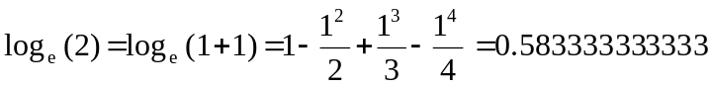

Truncated to 6 terms:

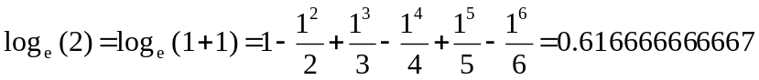

Truncated to 8 terms:

Accuracy of the estimated results against the actual calculator value

Using a calculator, log_{e}(2) is given as:

0.69314718056

If the calculator result is taken to be the exact value (X) with the truncated terms being taken as the estimates (x) the errors in the estimates (x) can be calculated using the equation below:

Error = X – x

- Error in the Maclaurin expansion evaluated to 4 terms =

0.69314718056 - 0.583333333333 = 0.109813847227

- Error in the Maclaurin expansion evaluated to 6 terms =

0.69314718056 - 0.616666666667 = 0.076480513893

- Error in the Maclaurin expansion evaluated to 8 terms =

0.69314718056 - 0.634523809524 = 0.058623371036

Comment on the Accuracy of the results:-

As the value of x is increased more terms are required to give an accurate result. Hence when a small value of x is used, less terms are needed to give the required accuracy.
Overall as a method for calculating the log_{e} of small numbers, it is a very accurate tool. However when evaluation of larger numbers are required bigger errors are apparent.

2).

The estimated value is:

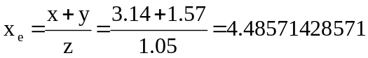

The estimated value is now calculated using the maximum error of 3 x 10⁻³ on the values of x, y and z.

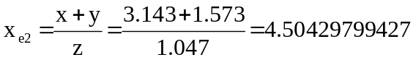

Worst case error:

x_{e2} – x_{e} = 4.50429799427 – 4.48571428571 = 0.01858370856

The exact value derived from the evaluation of (x + y)/z is:

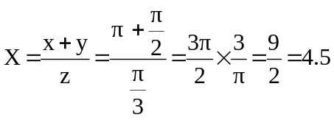
The relative error of the results is:-

Error = X – x_{e} = 4.5 – 4.48571428571 = 0.01428571429

Rearranging the equation for the calculation of the relative error

Relative error = actual error/ exact value

Actual error = relative error x exact value
Actual error = 0.01428571429 x 4.5
Actual error = 0.064285714305

Comparing the exact value of 4.5 with the estimated value (which uses a worst case error of 3 x 10⁻³) the worst case error is relatively small, when in comparison to the actual error. The actual error is in the order of 3 times the magnitude of the worst case error and 4-5 times the magnitude of the relative error.

3).

1st Arrangement that does converge:

x = ln (2cosx) = g(x)

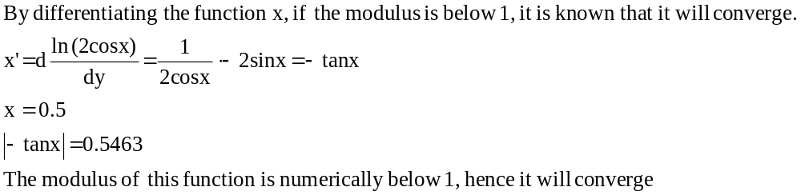

For x = 0.5 : g(0.5) = ln (2cos0.5) = ln(2 x 0.87758256189)

Ln (1.75516512378) = 0.562562940116

The result becomes the new x value, the equation is then re-applied as shown:-

x | cos x | 2 cos x | ln (2cos x)
0.5 | 0.877583 | 1.755165 | 0.562563
0.562563 | 0.845891 | 1.691782 | 0.525782
0.525782 | 0.864932 | 1.729863 | 0.548042
0.548042 | 0.853546 | 1.707092 | 0.534792
0.534792 | 0.860375 | 1.72075 | 0.54276
0.54276 | 0.856286 | 1.712573 | 0.537997
0.537997 | 0.858737 | 1.717474 | 0.540855
0.540855 | 0.857269 | 1.714538 | 0.539144
0.539144 | 0.858149 | 1.716297 | 0.540169
0.540169 | 0.857622 | 1.715243 | 0.539555
0.539555 | 0.857937 | 1.715875 | 0.539923
0.539923 | 0.857748 | 1.715496 | 0.539703
0.539703 | 0.857862 | 1.715723 | 0.539835
0.539835 | 0.857794 | 1.715587 | 0.539756
0.539756 | 0.857834 | 1.715669 | 0.539803
0.539803 | 0.85781 | 1.71562 | 0.539775
0.539775 | 0.857825 | 1.715649 | 0.539792

It can be seen that the value of g(x) has converged at 0.5398

2nd Arrangement that does converge:

x = ln 2 + ln(cosx) = g(x)

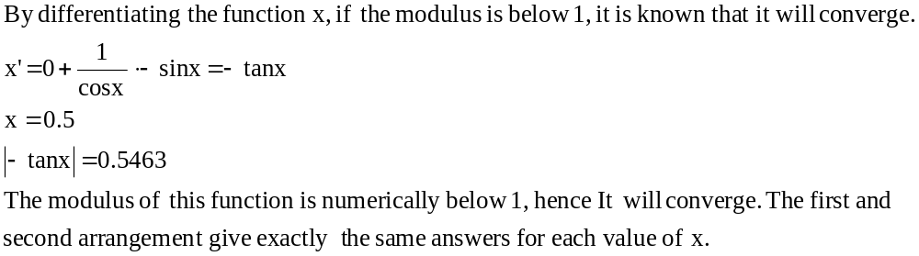

For x = 0.5 : g(0.5) = ln 2+ ln(cos0.5) = 0.69314718056+(-0.130584240444)

= 0.562562940116

The result becomes the new x value, the equation is then re-applied as shown. The results are identical to the previous pages results:-

x | cos x | 2 cos x | ln (2cos x)
0.5 | 0.877583 | 1.755165 | 0.562563
0.562563 | 0.845891 | 1.691782 | 0.525782
0.525782 | 0.864932 | 1.729863 | 0.548042
0.548042 | 0.853546 | 1.707092 | 0.534792
0.534792 | 0.860375 | 1.72075 | 0.54276
0.54276 | 0.856286 | 1.712573 | 0.537997
0.537997 | 0.858737 | 1.717474 | 0.540855
0.540855 | 0.857269 | 1.714538 | 0.539144
0.539144 | 0.858149 | 1.716297 | 0.540169
0.540169 | 0.857622 | 1.715243 | 0.539555
0.539555 | 0.857937 | 1.715875 | 0.539923
0.539923 | 0.857748 | 1.715496 | 0.539703
0.539703 | 0.857862 | 1.715723 | 0.539835
0.539835 | 0.857794 | 1.715587 | 0.539756
0.539756 | 0.857834 | 1.715669 | 0.539803
0.539803 | 0.85781 | 1.71562 | 0.539775
0.539775 | 0.857825 | 1.715649 | 0.539792

It can be seen that the value of g(x) has converged at 0.5398

Arrangement that does not converge:
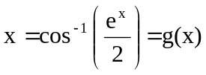

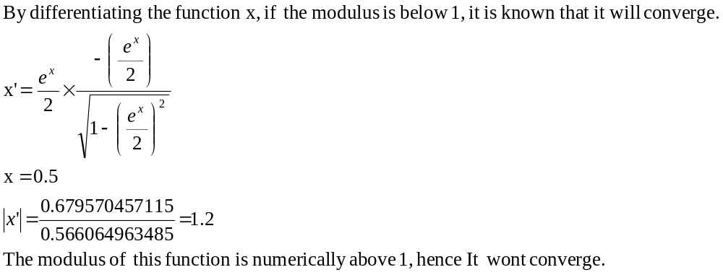

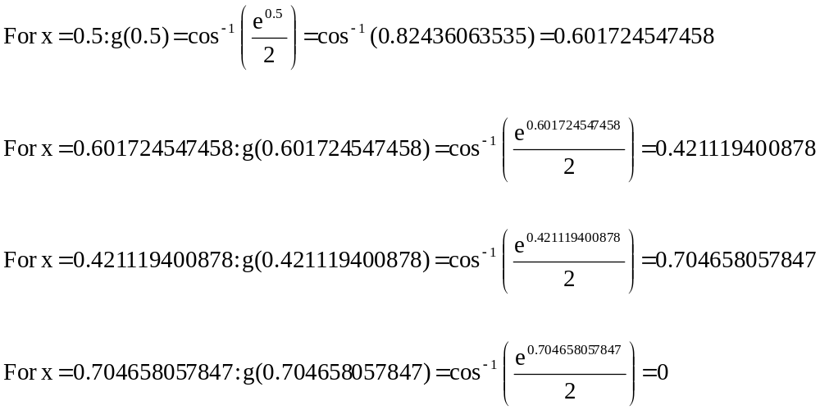

It can be seen that g(x) does not converge using this arrangement.

4).
i). Bisection Method

x³ – 11x² + 36x – 35 = 0

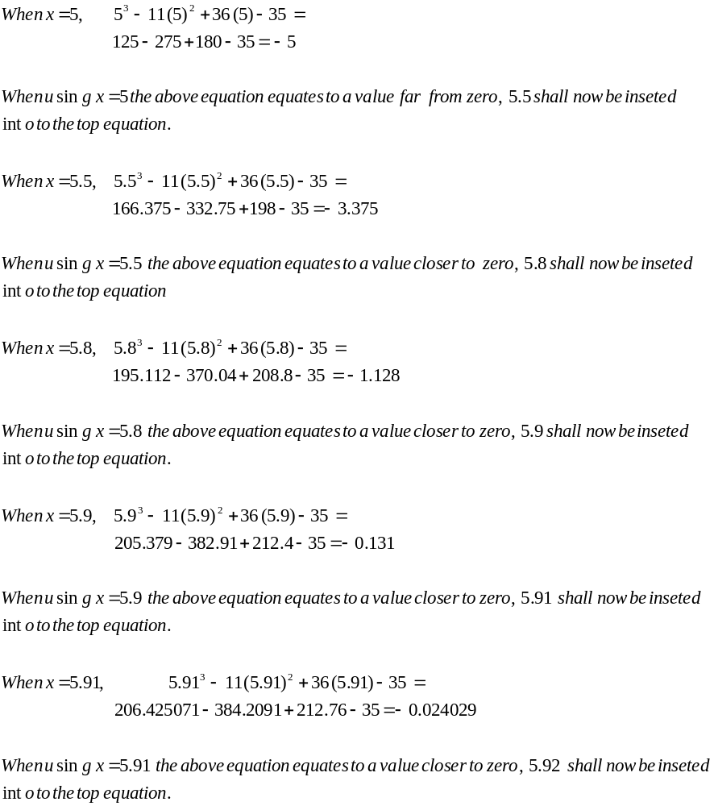

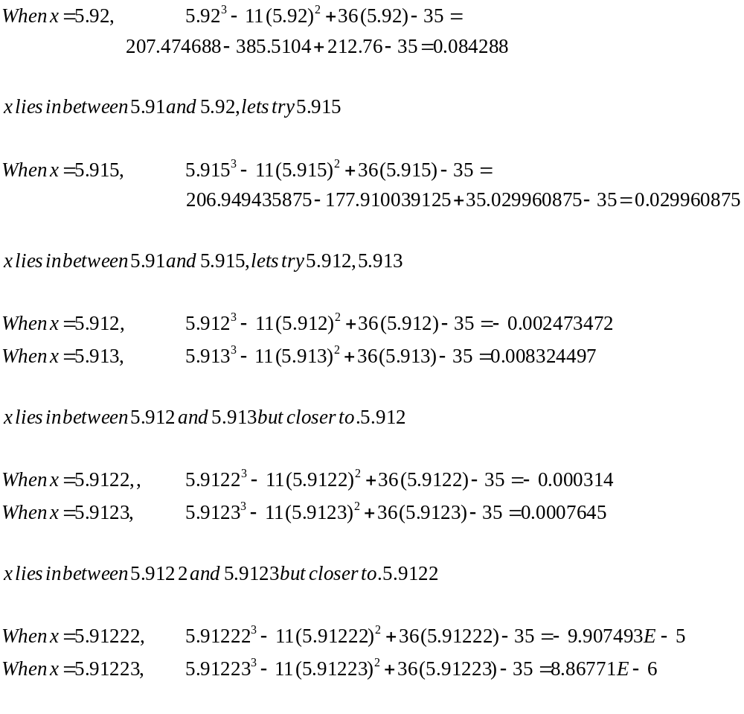
The root of the polynomial, accurate to 5 decimal places is 5.91223.
This method required 13 iterations. The method allows convergence to be analysed using a very simple method which can be memorised quickly. However the method takes a lot of time for convergence to occur.

ii). The linear interpolation of false position method

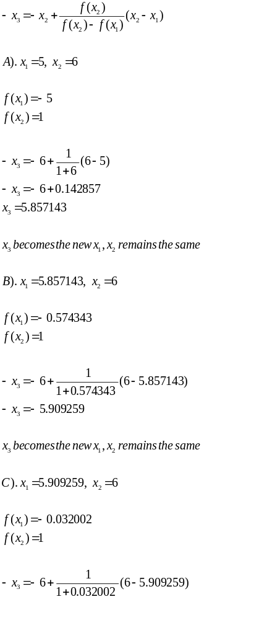

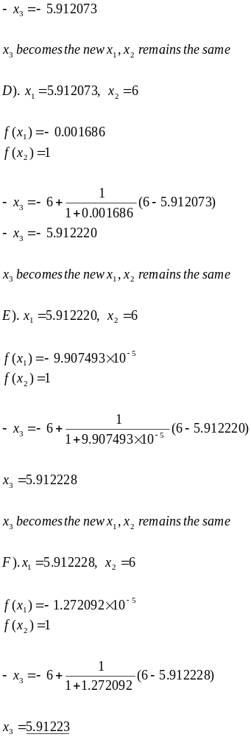

As can be seen above, the root of the polynomial accurate to 5 decimal places is 5.91223. This method required 6 iterations. The convergence method is trickier to use than the bisection method However the method takes less time to give the correct root.

iii). The secant method

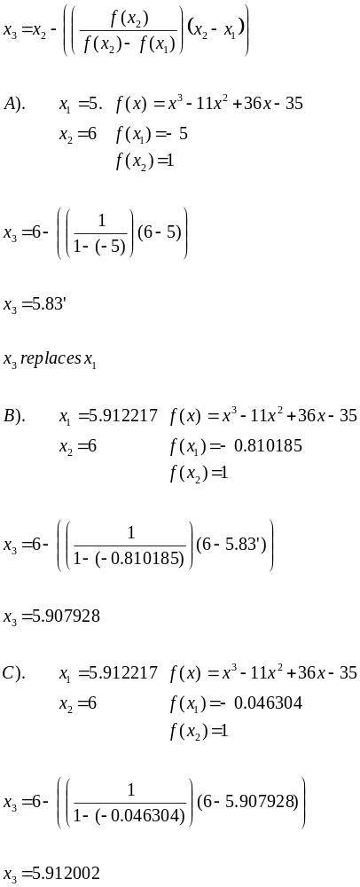
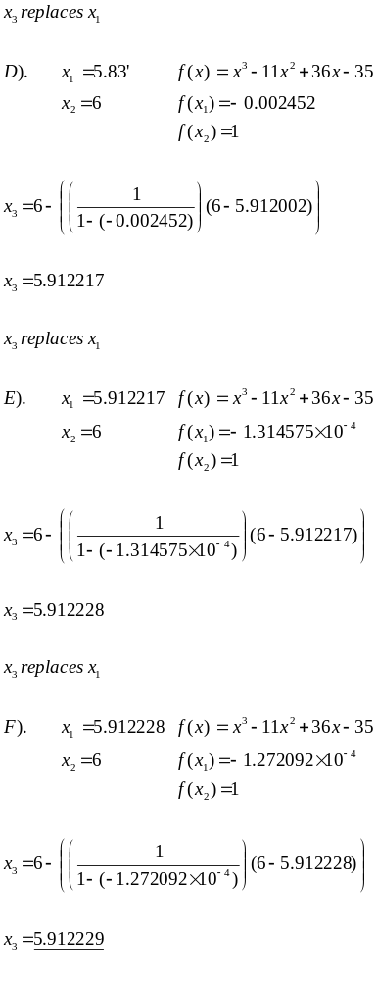
As can be seen above, the root of the polynomial accurate to 5 decimal places is 5.91223. This method required 6 iterations (same as the linear interpolation of false position method). The convergence method is basically the same as using the previous method but trickier to use than the bisection method. This method also less time to give the correct root.
iv). The Newton-Raphson

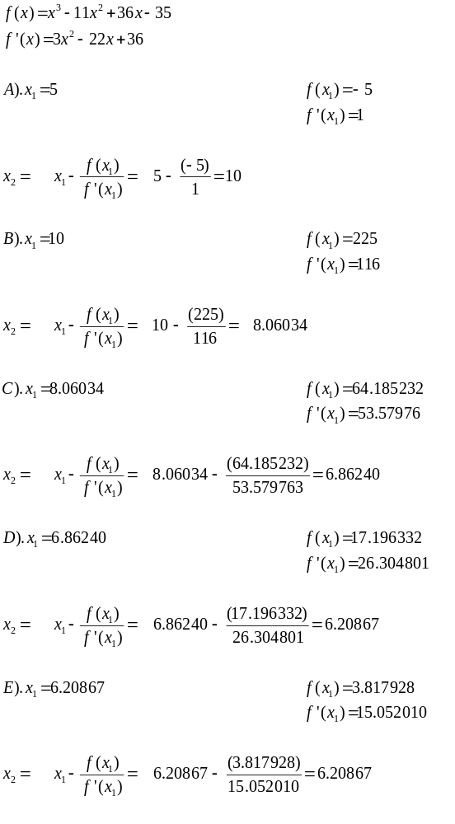

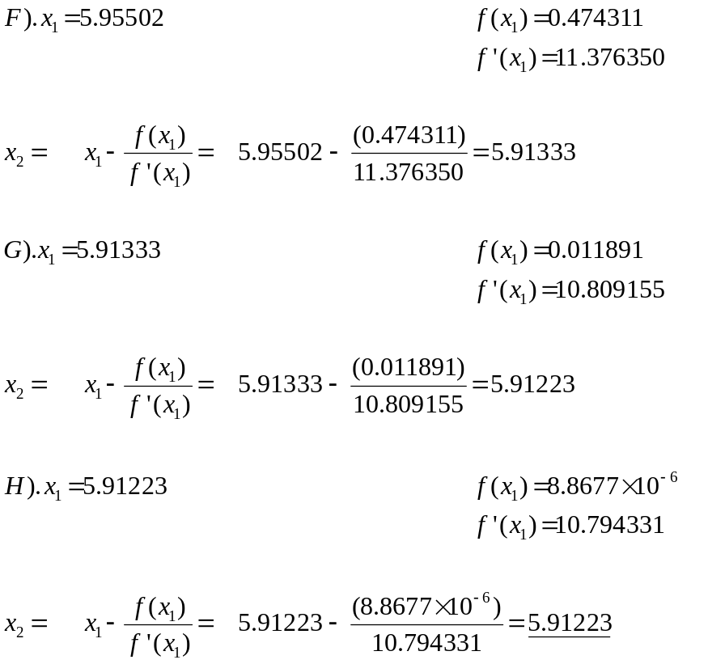

This method requires 8 iterations. Compare this with the previous two methods which require 6 iterations, and the fact that this method requires the derivative of f(x₁) to be calculated makes this method unfavourable.

5).
a)

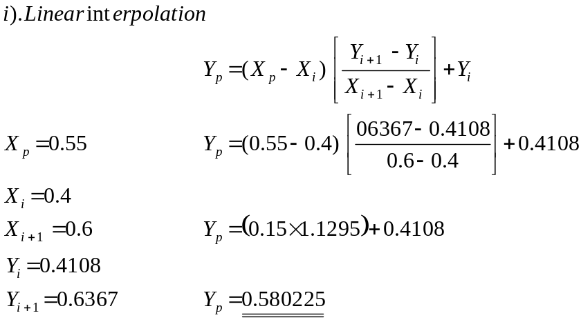

ii). Lagrange Polynomials

i |  | 0 |  | 2 |  | 3 |  | 5
X |  | 0 |  | 0.4000 |  | 0.6000 |  | 1
Y |  | 0 |  | 0.4108 |  | 0.6367 |  | 1.1752

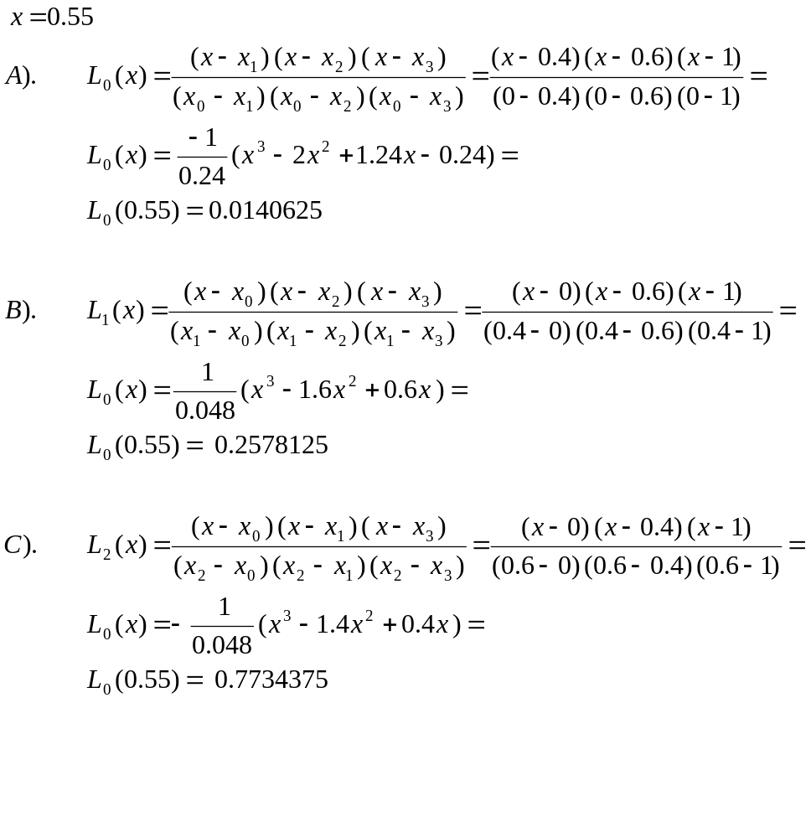
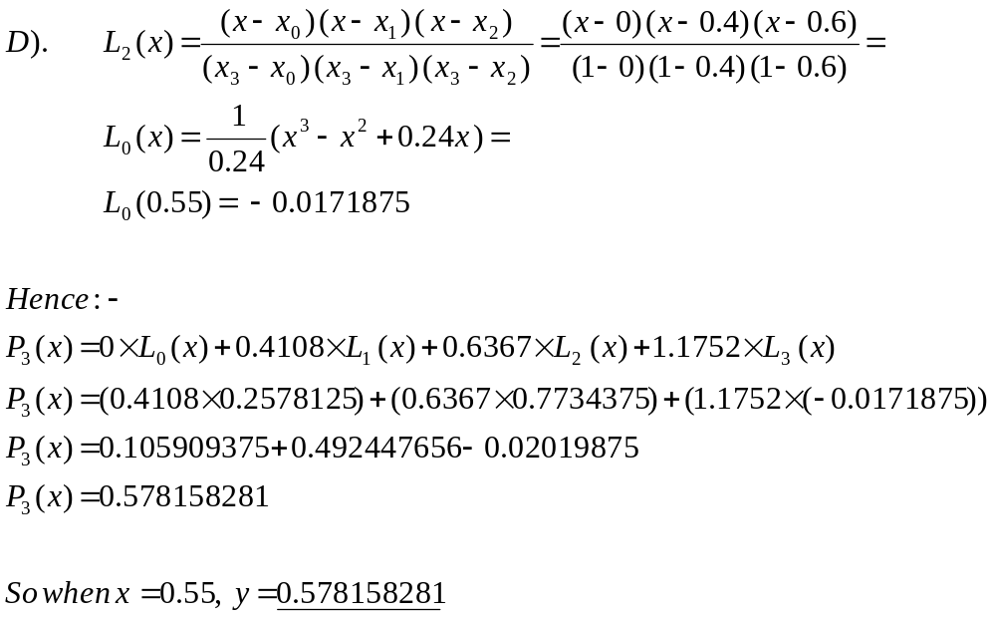

iii). Aitken’s method

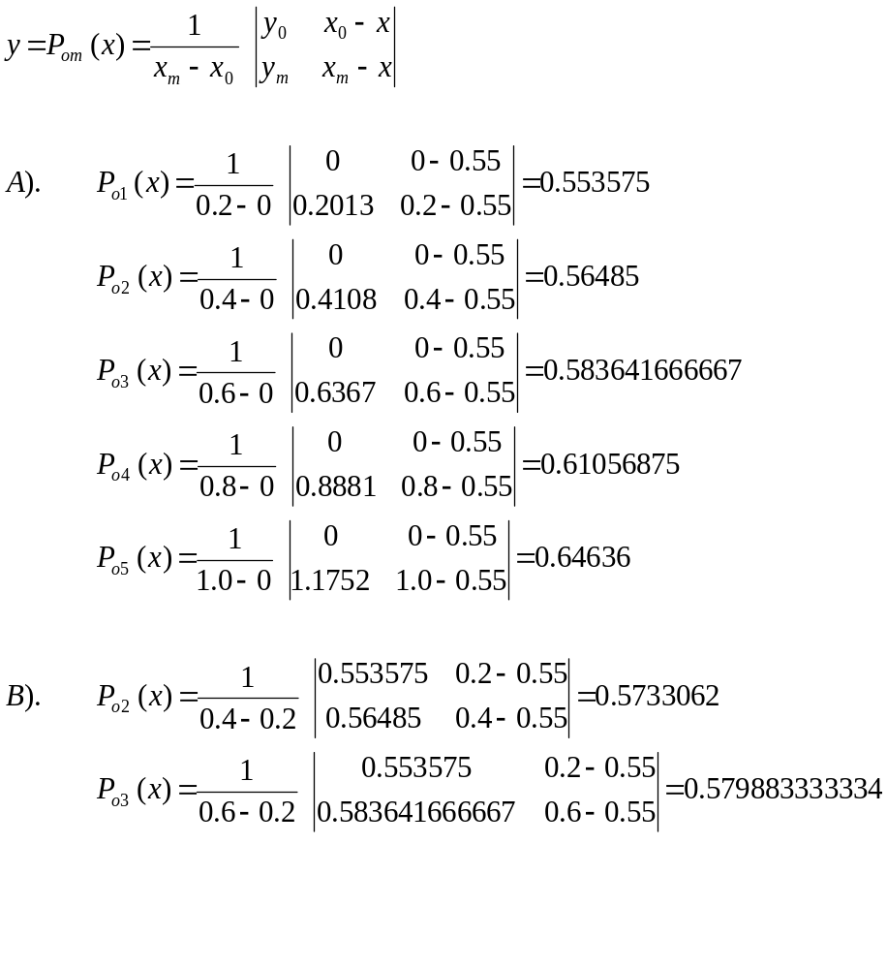

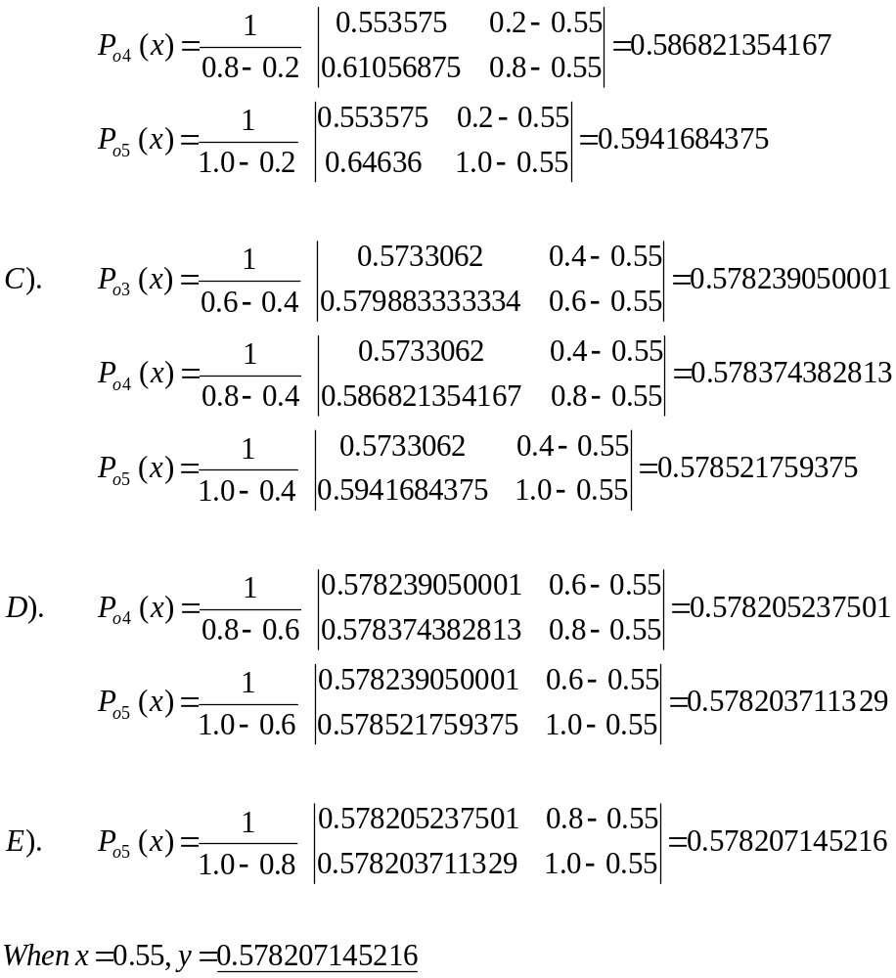

b). Method of least squares

n = 10
Σx_{i} = 52.6977
Σx_{i}² = 350.14368787
Σx_{i}³ = 2551.06379915
Σx_{i}⁴ = 19766.6037467
Σy_{i} = 269.4824
Σx_{i} y_{i} = 2060.72538952
Σx_{i}² y_{i} = 16726.538114

Substituting these coefficients into the equations below:-

na₀ + Σx_{i}a₁ + Σx_{i}²a₂ = Σy_{i}
Σx_{i} a₀ + Σx_{i}² a₁ + Σx_{i}³ a₂ = Σx_{i} y_{i}
Σx_{i}² a₀ + Σx_{i}³ a₁ + Σx_{i}⁴ a₂ = Σx_{i}² y_{i}

We have:-

10a₀ + 52.6977a₁ + 350.14368787a₂ = 269.4824
52.6977a₀ + 350.14368787a₁ + 2551.06379915a₂ = 2060.72538952
350.14368787a₀ + 2551.06379915a₁ + 19766.6037467a₂ = 16726.538114

Putting this into a 3x3 matrix we have:-

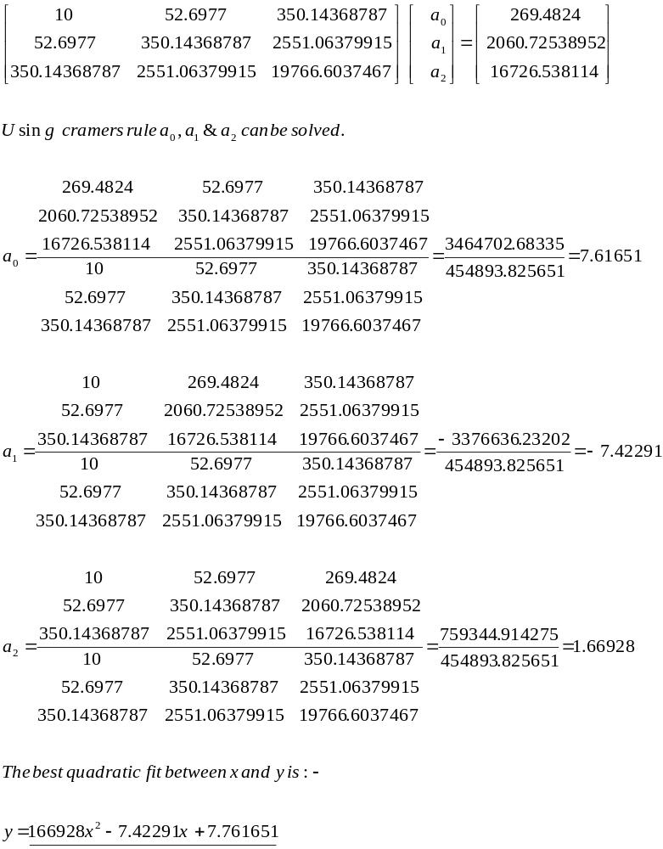

6).
i). Trapezoidal Rule

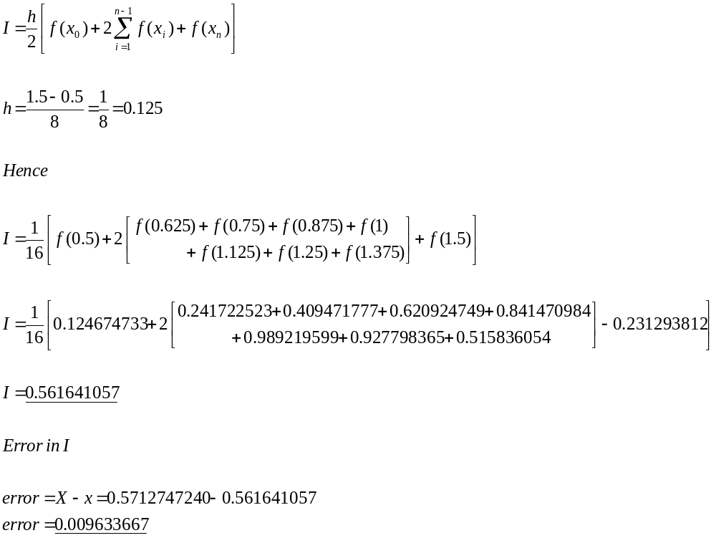
ii). Simpson’s Rule

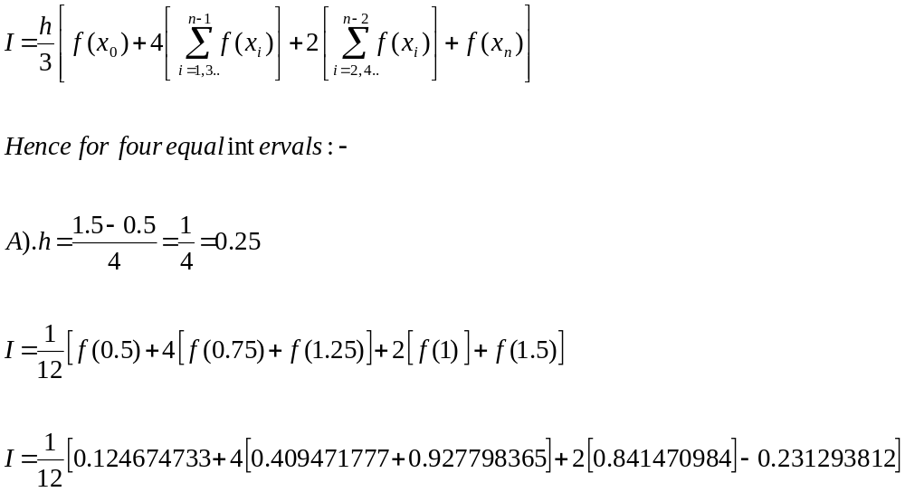
I = 0.57711695475

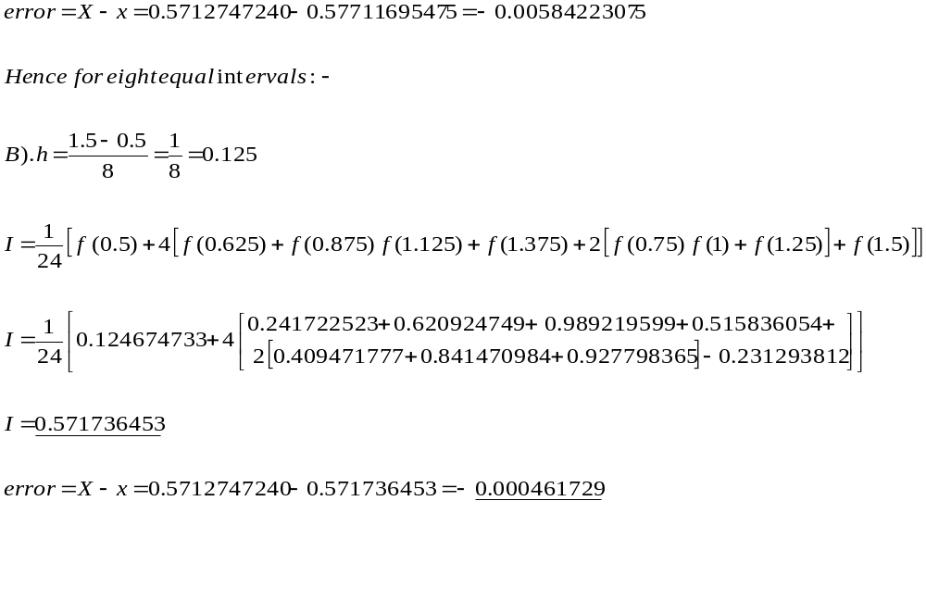iii). Gauss Method

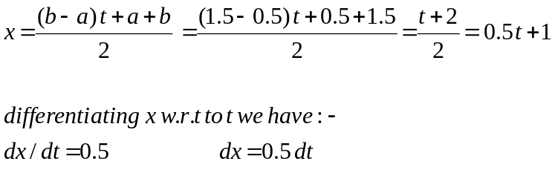

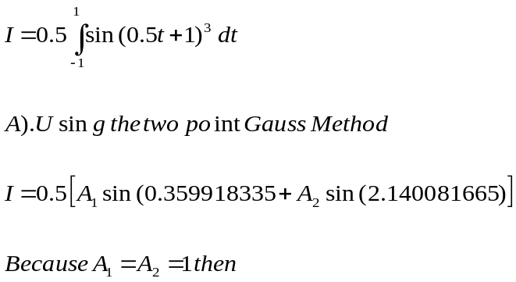

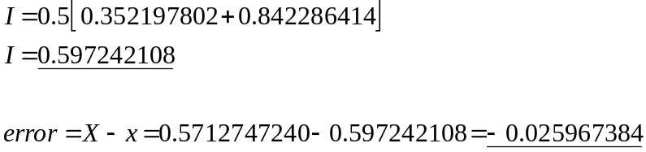

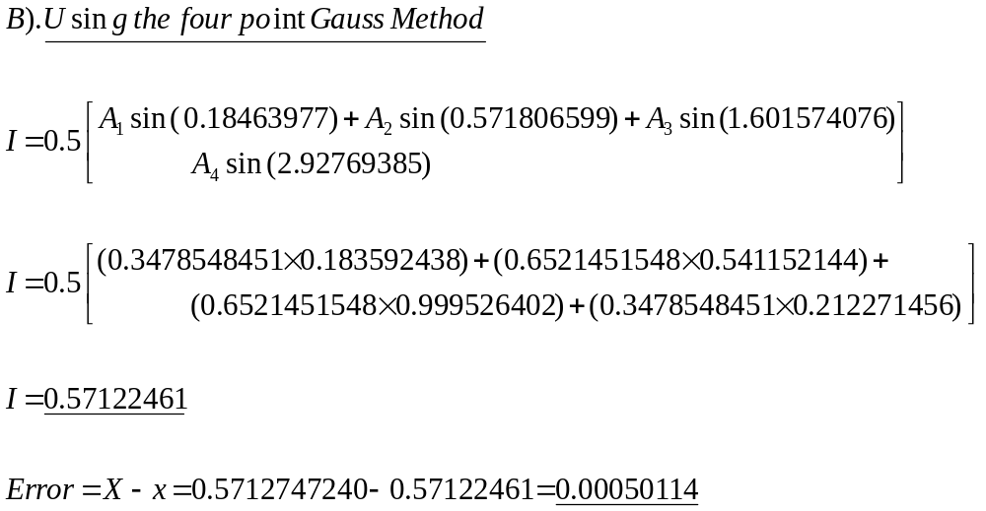

iv). Romberg Method

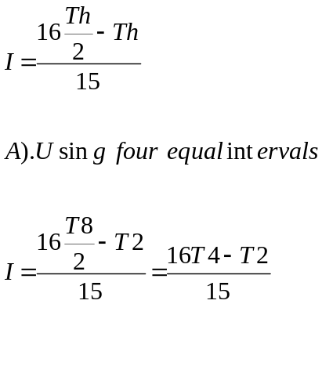

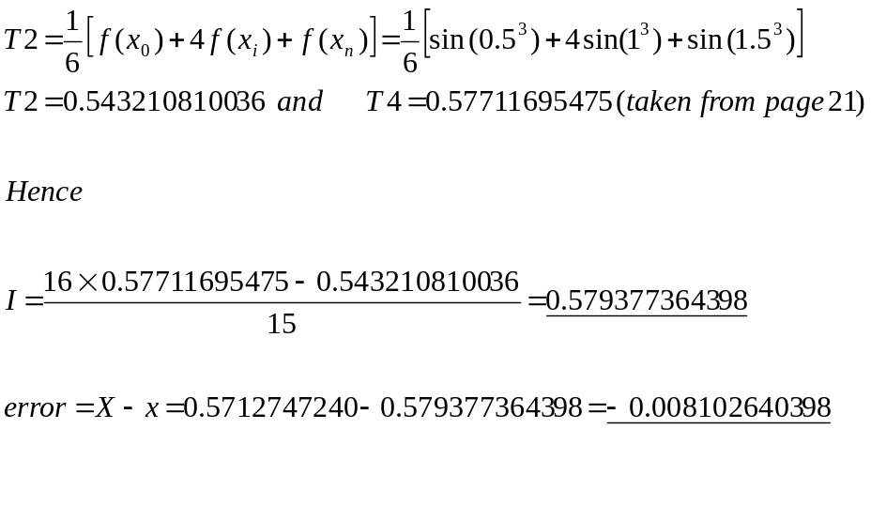

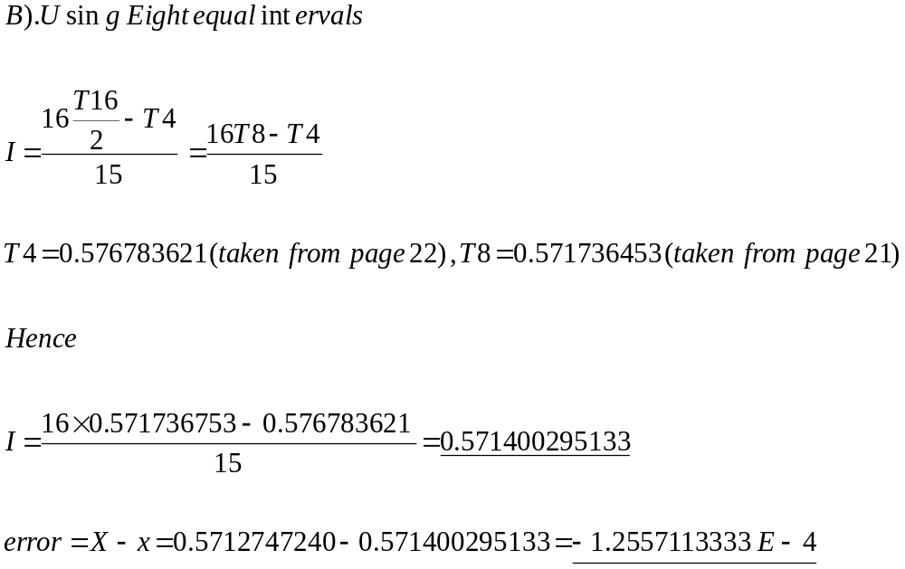

By taking a look at the error in each methods result in comparison to the actual answer it can be seen that the Romberg Method for eight equal intervals is the most accurate. With each method being of similar complexity, the Romberg Method which utilises the Simpson rule would be the method to use in similar assessments.

